**Creating SOAP Web Service with JAX-WS in NetBeans**

Step 1: Create a New Java Web Application Project

1. Open NetBeans IDE.
2. Click on "File" > "New Project..."
3. Choose "Java Web" > "Web Application" and click "Next."

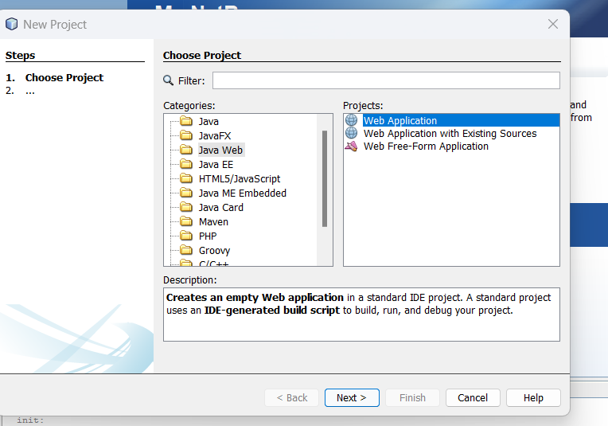

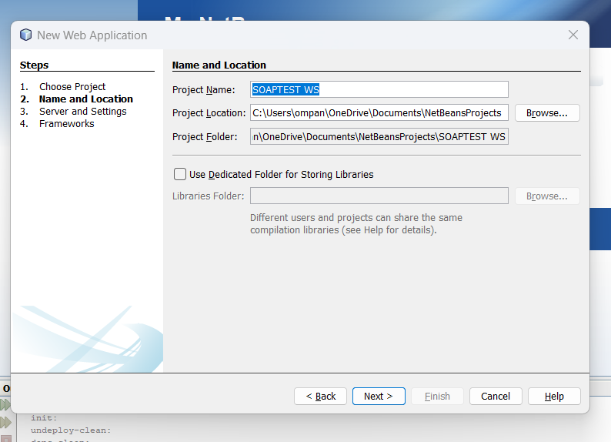

1. Select your server and Java EE version and click Finish.

Step 2:

1.Creating a Web Service from a Java Class

2.Right-click the SOAPTEST WS node in project section and choose New > Web Service

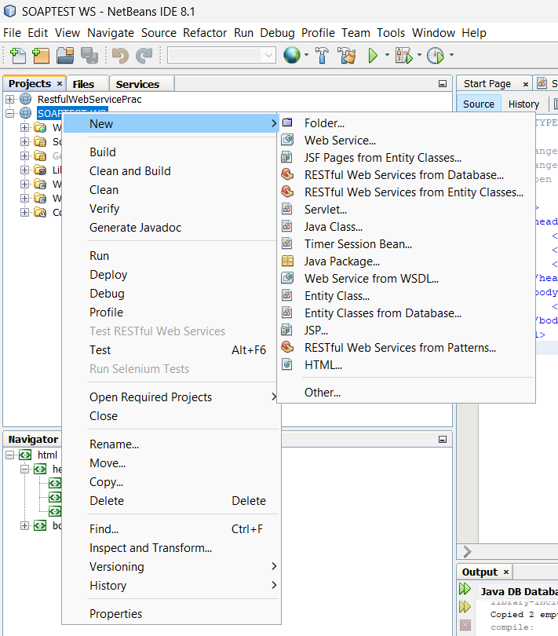

3.Provide Webservice name and package name

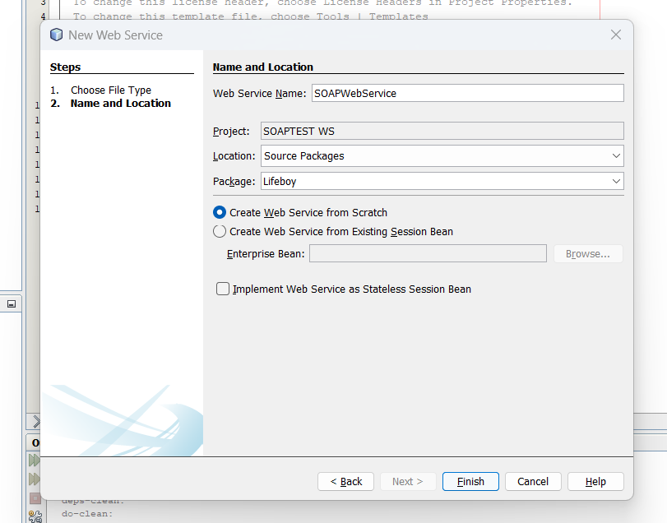

1. Click Finish. The Projects window displays the structure of the new web service and the source code is shown in the editor area

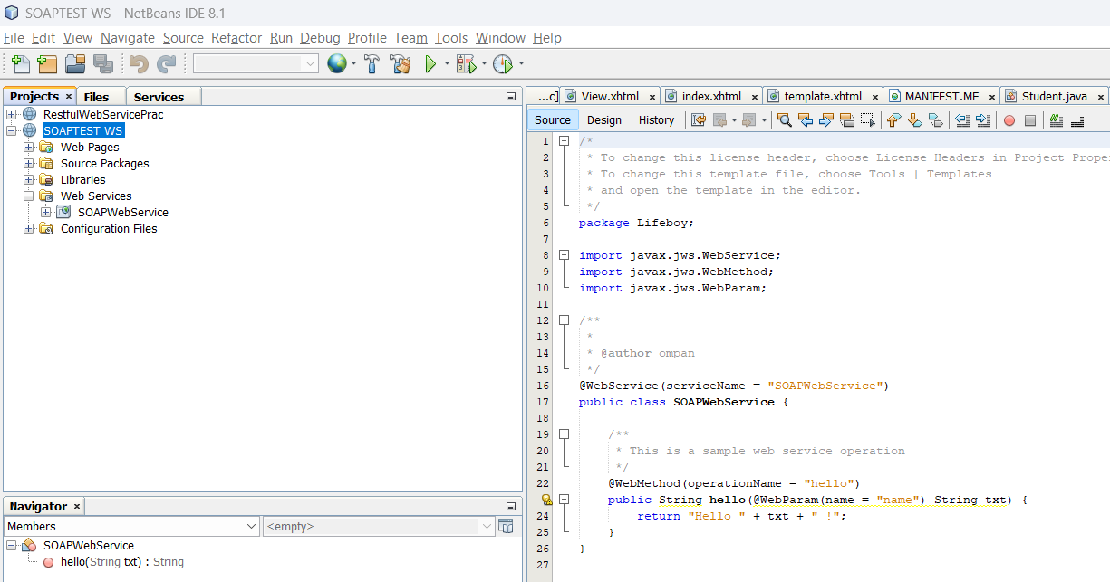

Step 3: Adding an Operation to the Web Service

To add an operation to the web service:

1. Either:

* Change to the Design view in the editor.

Or:

* Find the web service’s node in the Projects window. Right-click that node. A context menu opens.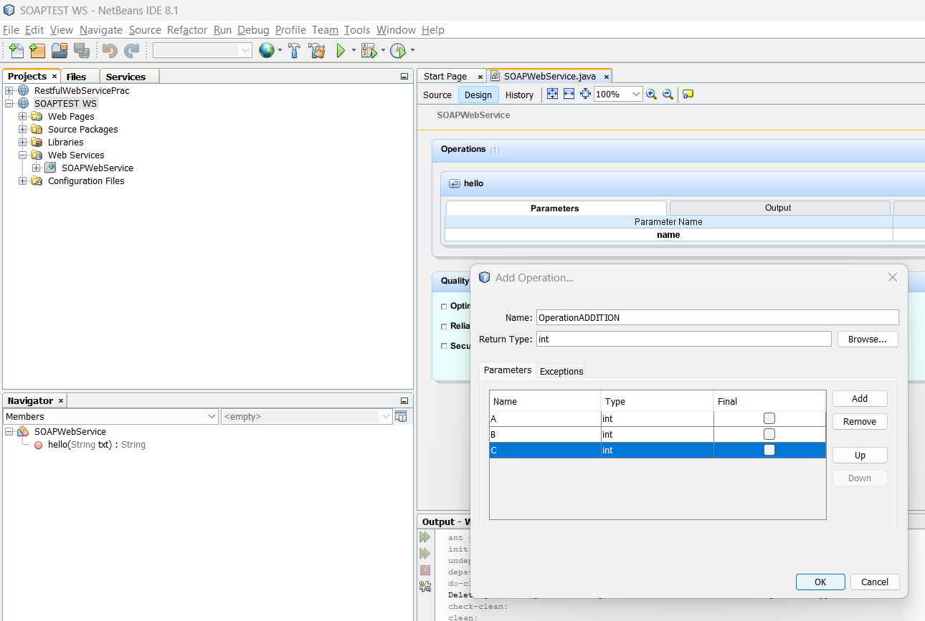

Step 4:

In code, write the required actions to be performed, in above addition operation will be **return (A+B+C);**

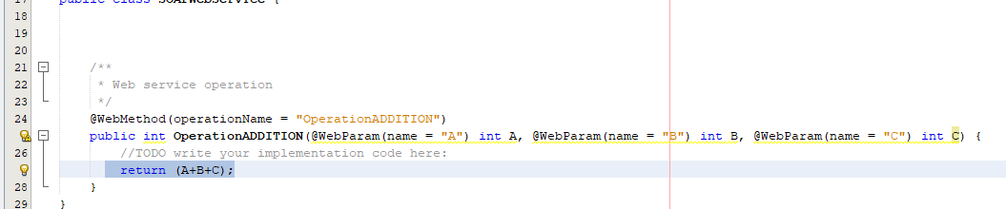

Step 5: Deploying and Testing the Web Service

1.To Deploy - Right-click the project and choose Deploy. The IDE starts the application server, builds the application, and deploys the application to the server.

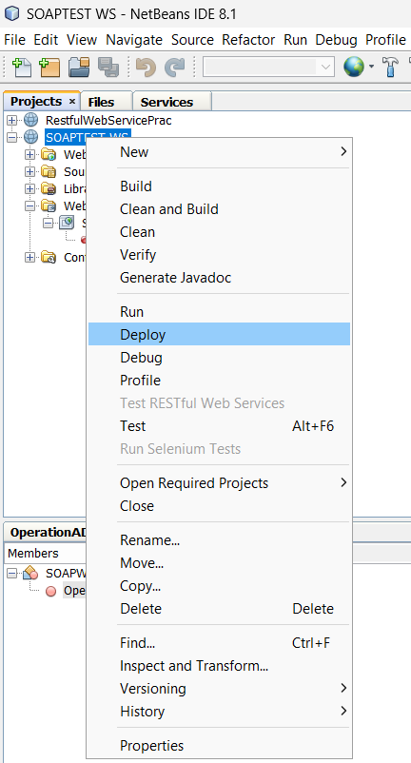

2.To test the webservice - In the IDE’s Projects tab, expand the Web Services node of the SOAPTEST WS project. Right-click the SOAPWebService node, and choose Test Web Service

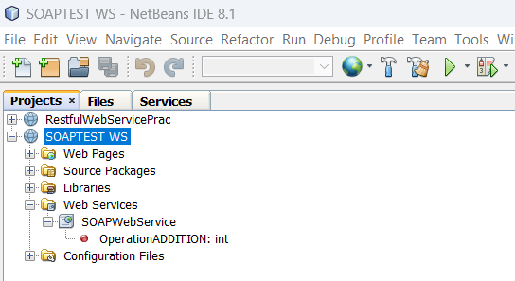

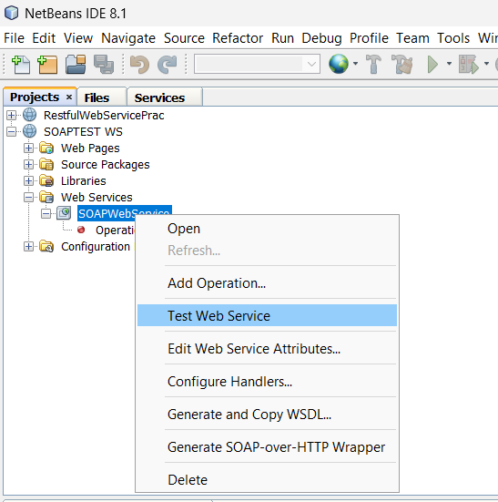

The IDE opens the tester page in your browser,

Output -

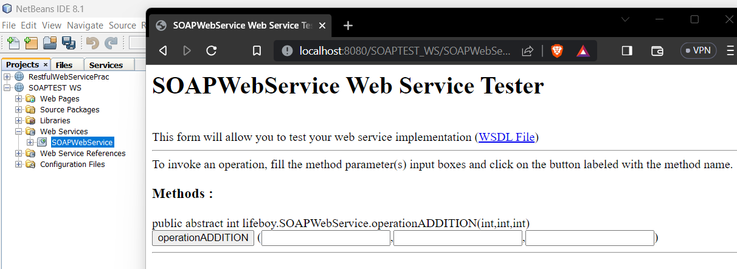

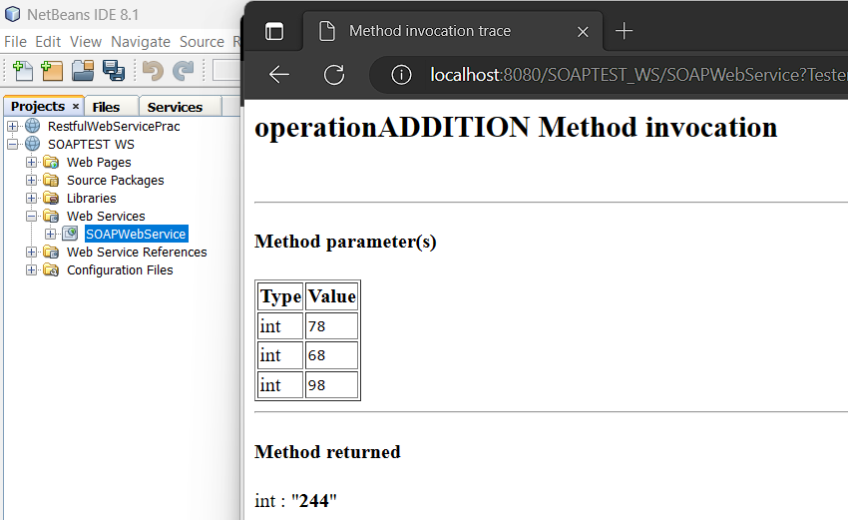

SOAP Request –

The provided XML code to be a SOAP envelope that describes a web service call to perform an addition operation

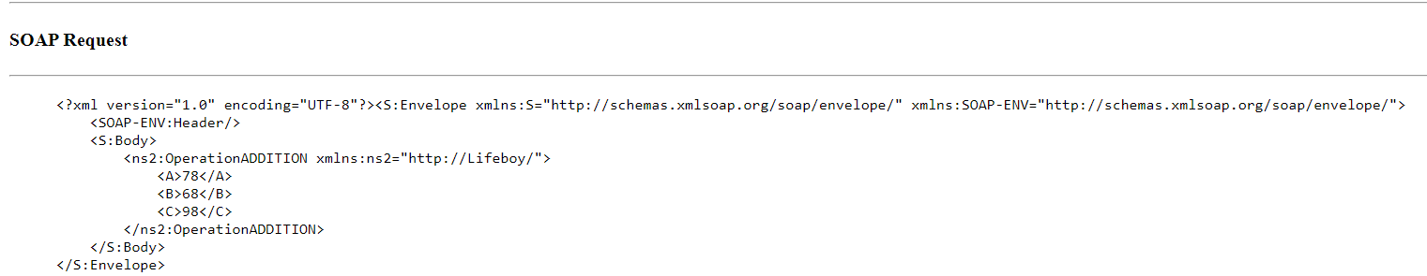

This XML makes a request to invoke a web service operation named "OperationADDITION" with input values A=78, B=68, and C=98, to perform an addition operation.

SOAP Response:

The SOAP response is the result returned from the server after processing the request. It indicates that the "OperationADDITION" operation was successful. The result of the addition operation (78 + 68 + 98 = 244) is enclosed within the <return> element.

